December 6, 2007

Wayne Spilove, Chairman
Philadelphia Historical and Museum Commission
State Museum Building
300 North Street
Harrisburg, PA 17120

Dear Mr. Spilove,

We again write to draw your attention to the preservation of the Philadelphia Life Insurance Building and its annex that are the subject of a binding agreement between PHMC and the Pennsylvania Convention Center Authority (PCCA). These two buildings are integral parts of an urban streetscape that includes the Pennsylvania Academy of Fine Arts, and other buildings nearby on North Broad Street that provide an authentic record of American commercial architecture over an extended period.

We understand that the PCCA still wishes to abrogate this agreement and has now advanced engineering and an unsubstantiated cost estimate in support of its position. We urge you not approve this request for the following reasons:

(1) The preservation of these structures is already the subject of an unconditional agreement.

(2) The preservation design has been prepared by a credible design team. This work has been paid for by the same authority that now wants to spend more money to change the design at this late state in the process.

Some advocates of demolition have suggested that the current preservation plan is somehow defective because it only proposes the preservation of the facades and adjacent twenty feet of each building. This argument is not persuasive because:

(1) The primary purpose of the proposed work is to protect the streetscape that is shaped by these facades.

(2) The current plan was reached after balanced consideration of the many other potentially historic buildings on the site that are now being demolished. It is too late to reopen the process.

We ask you, therefore, to continue to act to facilitate the preservation of these buildings that are part of a vital and unique streetscape. A draft of this letter, differing only in minor details, was unanimously approved at the regular meeting of the Design Advocacy Group (DAG) this morning.

Thank you for your consideration.

Sincerely yours,
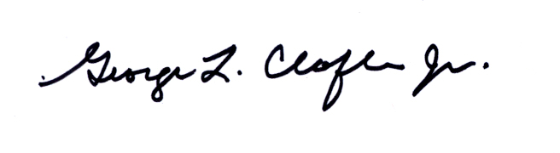
George. L. Claflen, Jr. FAIA
Vice-Chair for projects – DAG
Direct response to sender c/o dagwbmster@gmail.com or r
1619 Walnut Street, Suite 510, Philadelphia, PA 19103-5402 Tel 215-564-0878

Cc: Governor Edward G. Rendell
Mayor Elect Michael Nutter
Senator Vincent Fumo
Councilman Frank DiCicco
Inga Saffron, Philadelphia Inquirer

